**URDF Torso-YAW**

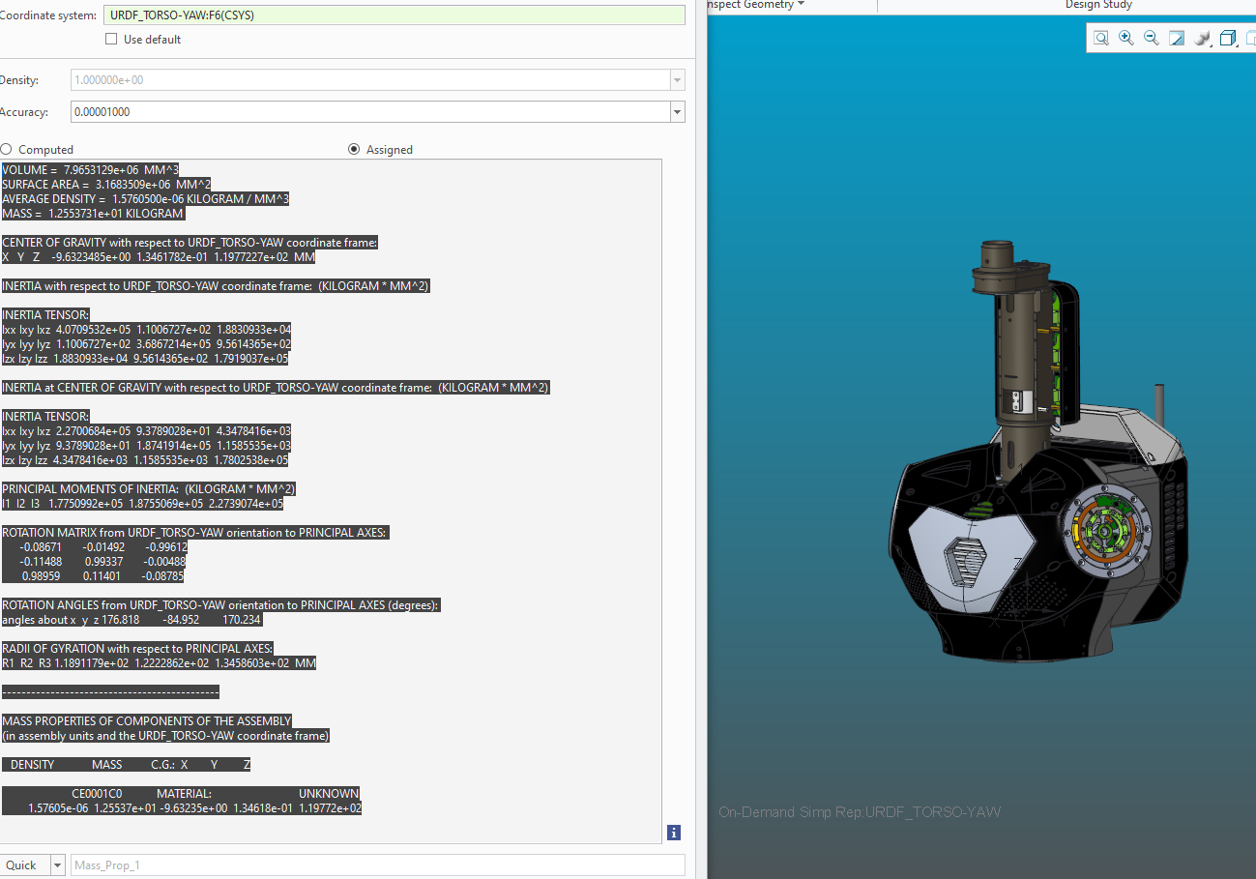

VOLUME = 7.9653129e+06 MM^3

SURFACE AREA = 3.1683509e+06 MM^2

AVERAGE DENSITY = 1.5760500e-06 KILOGRAM / MM^3

MASS = 1.2553731e+01 KILOGRAM

CENTER OF GRAVITY with respect to URDF_TORSO-YAW coordinate frame:

X Y Z -9.6323485e+00 1.3461782e-01 1.1977227e+02 MM

INERTIA with respect to URDF_TORSO-YAW coordinate frame: (KILOGRAM * MM^2)

INERTIA TENSOR:

Ixx Ixy Ixz 4.0709532e+05 1.1006727e+02 1.8830933e+04

Iyx Iyy Iyz 1.1006727e+02 3.6867214e+05 9.5614365e+02

Izx Izy Izz 1.8830933e+04 9.5614365e+02 1.7919037e+05

INERTIA at CENTER OF GRAVITY with respect to URDF_TORSO-YAW coordinate frame: (KILOGRAM * MM^2)

INERTIA TENSOR:

Ixx Ixy Ixz 2.2700684e+05 9.3789028e+01 4.3478416e+03

Iyx Iyy Iyz 9.3789028e+01 1.8741914e+05 1.1585535e+03

Izx Izy Izz 4.3478416e+03 1.1585535e+03 1.7802538e+05

PRINCIPAL MOMENTS OF INERTIA: (KILOGRAM * MM^2)

I1 I2 I3 1.7750992e+05 1.8755069e+05 2.2739074e+05

ROTATION MATRIX from URDF_TORSO-YAW orientation to PRINCIPAL AXES:

-0.08671 -0.01492 -0.99612

-0.11488 0.99337 -0.00488

0.98959 0.11401 -0.08785

ROTATION ANGLES from URDF_TORSO-YAW orientation to PRINCIPAL AXES (degrees):

angles about x y z 176.818 -84.952 170.234

RADII OF GYRATION with respect to PRINCIPAL AXES:

R1 R2 R3 1.1891179e+02 1.2222862e+02 1.3458603e+02 MM

---------------------------------------------

MASS PROPERTIES OF COMPONENTS OF THE ASSEMBLY

(in assembly units and the URDF_TORSO-YAW coordinate frame)

DENSITY MASS C.G.: X Y Z

CE0001C0 MATERIAL: UNKNOWN

1.57605e-06 1.25537e+01 -9.63235e+00 1.34618e-01 1.19772e+02

**T-matrix Pelvis to Torso – Yaw**

1.00000 0.0000000000 0.0000000000 200.000

0.0000000000 1.00000 0.0000000000 0.0000000000

0.0000000000 0.0000000000 1.00000 256.000

